**Integrate Jenkins with nexus:**

* Create the two ec2 instance one for Jenkins and another for Nexus.
* Install the java on two servers (java 17 version is required for nexus)and open the port no.8081 for nexus.
* Install the maven and Jenkins on Jenkins server(from jenkis.io).
* Connect to the nexus server and create the nexus user by using **adduser username** command.
* Switch to the user by using **su – username** command.
* Install the nexus( from [Download (sonatype.com)](https://help.sonatype.com/en/download.html))
* Use the below command

wget <https://download.sonatype.com/nexus/3/nexus-3.73.0-12-unix.tar.gz>

* Untar the above file by using **tar -zxvf nexus-3.73.0-12-unix.tar.gz** command.
* Change the owner permission by using **chown nexus:nexus nexus-3.73.0-12 -R** command.
* Give the file permissions by using **chmod 777 nexus:nexus nexus-3.73.0-12 -R** command.
* Enter **ll** command go to nexus directory by using **cd nexus-3.73.0-12** command .
* Enter **ll** and go to bin directory by using **cd bin** command.
* Enter **ll** and open this file by using **vi nexus.rc** command and add the username .
* Start the nexus by using **sh nexus start** command.
* Copy the public i.p of nexus server and paste it on browser.Now access the nexus .
* Enter the user name is admin and enter the password from that path which is showing while login.
* Create the repository in the nexus.
* Log into Jenkins server and Install the nexus artifactory from plugins.
* Configure the all details like group id,version,nexus repo name,artifact id,type of artifact(war or jar or ear),file path(from Jenkins server we can go to this path /var/lib/Jenkins/workspace/job name/target/war file name) while generating the pipeline script by using pipeline syntax.

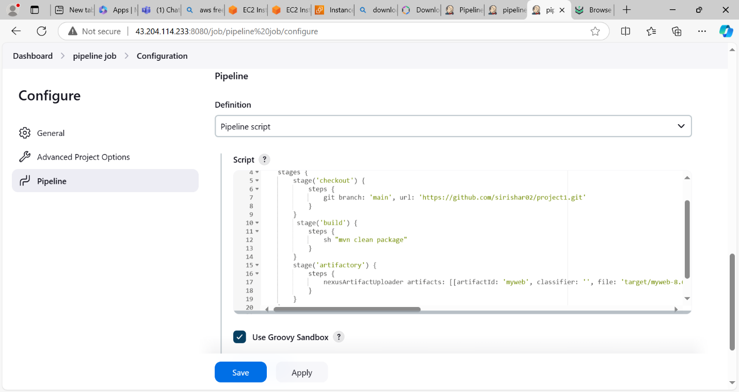

Build success

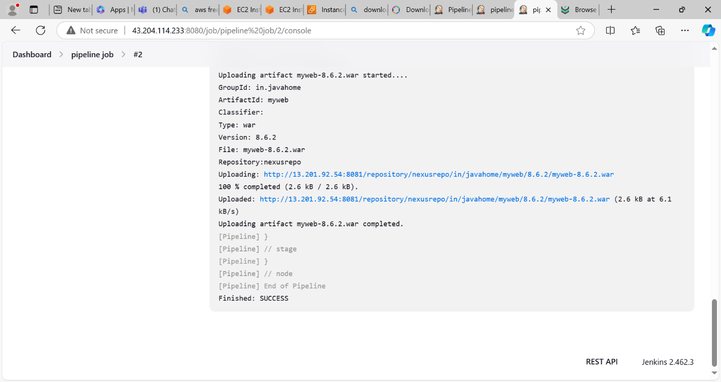

Store the artifact in Nexus Repo

